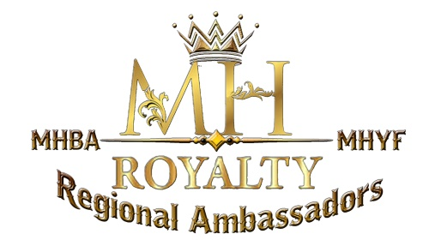

Regional Miniature Hereford Ambassador
2022 Application

Qualifications:
- Applicant must be an active Family or Junior member of the MHBA .
- Applicant must be 13 year of age, but not turn 20 years of age prior to January 1st.
- Applicant must be an owner or co-owner of a registered Miniature Hereford.
- Applicant must hold a current paid membership with the MHBA thru their term in office without allowing it to lapse at any time.
- Applicant must be able to fulfill their duties as Regional Ambassador during their term. (see duties list in Royalty Rules and Expectations)
Requirements:
- Applicant will submit a complete application as well as the following
  - Recent 5x7 photograph
  - Participate in person interview or by telephone
  - Completed photo/information release form
  - Sign a Code of Conduct contract
- Applicant must follow and adhere to all MHBA and Royalty rules set forth by the Association.
- Applicant must be chaperoned by a parent or guardian on any overnight National, Regional, or local Miniature Hereford event.
- As a Regional Ambassador you must be un-married and have no children.
- As a Regional Ambassador you will be encouraged to attend the Miniature Hereford Breeders Association World show in Denver, CO each year.
  - At this event you will participate in Royalty duties and activities.
  - The new Ambassadors are selected and introduced at this event.
- As the Regional Ambassador you must attend at least one of your Regions State Fairs, Expos or National Miniature Hereford shows.
- As the Regional Ambassador you must stay in contact with their MHBA Regional Director providing information regarding the shows and events in which they will be attending representing the MHBA/Royalty.
- As the Regional Ambassador you are encouraged to attend the MHBA/MHYF Junior Nationals.

- As the Regional Ambassador you are an advocate on behalf of the cattle industry and agriculture on a National, Regional, State, and local level. You should promote the Miniature Hereford breed through different venues including but not limited to parades, visiting schools, 4H meeting, and FFA Events. (All Code of conduct and clothing rules should be followed as well as wearing your Ambassador attire)
- As the Regional Ambassador you are not required to participate in any show/venue that you attend representing the MHBA/Royalty.
- Duties of the Regional Ambassador at any MHBA event shall be to assist the National Queen and Princess with their duties, handing our ribbons, helping the judge and show Superintendent, talking to the public, having your picture taken with exhibitors, as well as any other duty requested of you during that event.

All completed Applications shall be sent via email to the MHBA Royalty Chairperson. Upon receipt of application the Royalty Committee shall review all applications and after the interview process (if necessary) shall select the following year’s Regional Ambassador Representatives.
2021-2022 Royalty Chairperson
Erin Eldridge
Email: cowqueen19987@gmail.com
541-619-7008

Selection Process for Candidates
All candidates will be judged according to the MHBA/Royalty application policies. Each application will be judged on completeness of application, quality of essay questions, and interview if necessary (in person or telephone).
Announcement of winners will be done at the 2022 MHBA World show meeting/Banquet. Attendance is not required by highly suggested.

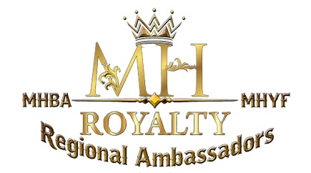
2022 MHBA Regional Ambassador Application

Applicant Name: Click here to enter text.
MHBA Member number: Click here to enter text.Date of Birth: Click here to enter text.
Address:Click here to enter text.
City:Click here to enter text.State: Click here to enter text. Zip code:Click here to enter text.
Email: Click here to enter text. Phone: Click here to enter text.
Parent/Guardian: Click here to enter text.
Address if different than applicants: Click here to enter text.
Email: Click here to enter text. Phone:Click here to enter text.
School Attending: Click here to enter text. Grade in School:Click here to enter text.
School Email: Click here to enter text.
Number of Miniature Herefords you own or Co-own: Click here to enter text.
How long have you owned Miniature Hereford Cattle: Click here to enter text.

ESSAY:
Why would you like to be a Regional Ambassador for the Miniature Hereford Breeders Association?
Click here to enter text.

ESSAY:
How can you help promote the Miniature Hereford breed to other cattle owners as well as the general public?
Click here to enter text.

ESSAY:
What are your future goals and do they include the Miniature Hereford Breed? How? (250 word minimum)
Click here to enter text.

If selected to represent my Region as well as the Miniature Hereford Breeders Association I acknowledge that I will be responsible for representing our Association and the Miniature Hereford breed to the best of my ability. By signing this application I agree to follow all MHBA and Royalty rules, policies, expectations, and Code of Conduct.
Signature: _________________________________ Date: Click here to enter text.
Parent/Guardian Signature: ___________________________________________

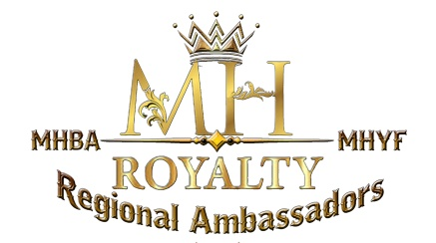
MHBA/ MHYF Royalty Code of Conduct
Contract
As a member of the Miniature Hereford Breeders Association you are a role model to the youth across the country as well as a Representative for the Miniature Hereford Breed. All actions you take during your service do affect the MHBA, MHYF and the Royalty you represent. Therefore, it is of the utmost importance that you act in an appropriate manor at all times while you are in the public’s eye attending livestock functions. If it is determined that you are acting, or have acted in a manner that is inappropriate according to the guidelines set below, the MHBA, MHYF, and the Royalty chairperson have the right to take whatever action is deemed necessary.
- No consumption of alcoholic beverages. You should not put yourself in a position to be drinking with fellow junior members, adults, or in the public eye of other livestock personnel.
- No use of drugs or tobacco products
- No commission of a crime
- No foul or inappropriate language
- No bulling

The MHBA, MHYF, and the Royalty Chairperson hold the right to make additional rules and requirements as they are needed.
I understand and agree to abide by the above statements.

Signature: _________________________________ Date: lick here to enter a date.
Parent/Guardian Signature: ______________________________________

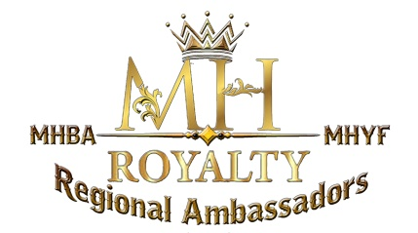
MHBA/MHYF Royalty Dress Code
Contract
As representatives of the MHBA, MHYF, and the Royalty Program, you are always in the public’s eye. Producers, breeders, customers, peers, are always watching you, what you are doing, and especially what you are wearing. The following is a dress code you should adhere to during your time in service.
Skirts: Should be modest, clean, and Ankle length or longer.
Shirts: Should be long enough to be tucked in. They should be ironed with no frays or tears. Absolutely no tank tops. T-shirts when required at shows you are attending. These t-shirts must be new, clean, and appropriate for the venue.
Pants: Jeans, Khakis, dress slacks are permitted. Please make sure that they are not faded, torn or frayed.
Shoes and boots: Please keep shoes and boots clean and polished if possible.
Ambassadors Attire: Ambassador Polo Shirt and Pin must be worn at all events. Be sure your shirt is clean, neat, and tucked in.
Junior Princess Attire: Be sure attire is clean with no fading, fraying, or holes. Sash/crown must be worn while in the ring assisting with the show, having pictures taken, or doing public appearances. Sash and crown may not be worn while showing. You will be required to wear an ankle length skirt with boots at all events where you are representing the position of National MHBA Junior Princess.
Princess Attire: Be sure attire is clean with no fading, fraying, or holes. Sash/crown must be worn while in the ring assisting with the show, having pictures taken, or doing public appearances. Sash and crown may not be worn while showing. You will be required to wear an ankle length skirt with boots at all events where you are representing the position of National MHBA Princess.
Queen Attire: Your crown and sash should be worn at all required events and kept clean and neat. The Queen sash is handed down from Queen to Queen. It is to be kept in exceptional state using the handed down box to store it in. Sash and crown may not be worn while showing. You will be required to wear an ankle length skirt with boots at all events where you are representing the position of National MHBA Queen.
Try to avoid loud colors that stand out in a photo. The focus of any picture should be the animal and exhibitor, not you. Use your best judgment in your clothing selection. If you need to question your outfit, it is probably not appropriate.
I understand and agree to abide by the above statements.

Signature: _____________________________ Date: Click here to enter a date.
Parent/Guardian Signature: _________________________________

MHBA/MHYF Royalty Photo Release
Form

I hereby grant permission to the MHBA, MHYF, and the Royalty Chairperson to use any and all photographs and/or videos taken of me at local, regional and national shows, members’ sales/auctions, club gatherings, parades, and other events. These may be used in publications, online, news releases, and in other communications related to the Miniature Hereford Association, Foundation, and the Royalty program.

Signature: _____________________________ Date: Click here to enter a date.
Address: Click here to enter text.
City: Click here to enter text. State:Click here to enter text. Zip: Click here to enter text.
Email: Click here to enter text. Phone: Click here to enter text.
Signature of applicant or parent/guardian if under the age of 19.
Signature: ___________________________ Date: Click here to enter a date.

