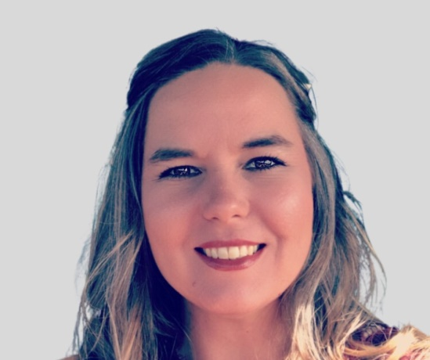
Howdy, I am Andrea Trapp, I am honored to have been nominated by our Miniature Hereford Breeders for the Miniature Hereford Breeders Association Board Secretary. I am originally from Harlingen, Texas where I grew up on a Farm & Ranch where we raised commercial cattle along with row crops. I currently live in Lyford, Texas with my husband, Kevin Trapp, and our daughter Montanna Trapp.
In 2015 as a family, we purchased our first Miniature Hereford for Montanna’s very first 4-H project and established Trapped In Time Miniature Herefords, we were the first family to bring Miniature Herefords to the Rio Grande Valley. Since 2015 we have grown our herd to thirty head. We have been incredibly involved in the show circuit from our County shows to National Shows.
Since 2016 we have worked with the Rio Grande Valley Livestock Show & Rodeo to add a division for our Miniature Herefords, from 2016 to 2019 Miniature Hereford cattle were shown with big cattle in the AOB (All Other Breeds) Division. Finally in 2020 we were able to have our own Miniature Hereford Show during the Rio Grande Valley Livestock Show and Rodeo. We started out with 1 Miniature Hereford in 2016 and this year at the 2023 Rio Grande Valley Livestock Show & Rodeo we had 60 head and added the Get of Sire, Produce of Dam and we finally were able to get the Rio Grande Valley Livestock Show & Rodeo Board approval to allow our Pre-Junior show kids to show in our Open Show! Our Miniature Hereford Breed and Kiddos have a bright future in the Rio Grande Valley and the Rio Grande Valley Livestock Show!
I share this with you, our voting members because I along with my family are committed to not only growing the Miniature Hereford Breed in our show industry as well for our commercial breeders, we are committed to our members and our youth across the country to improve our breed, set standards for our breed not only in the show industry but across all facets of our industry through communication to publications, to working with other Breed Associations to continue to improve our breed.

