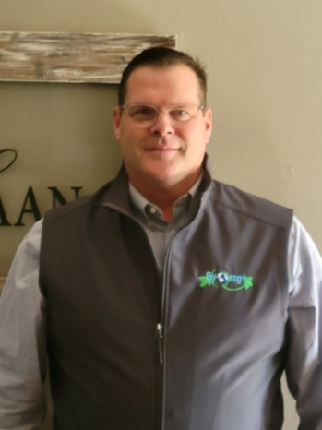
My name is Craig De Haan, and I am truly honored to be nominated for this position. My wife, Sandi, and I live on a small acreage on the edge of Orange City, IA. We are located in the very NW corner of Iowa and we both grew up on family farms. I purchase my family farm (considered an acreage now due to the small-town closing in around me) in 1991 and still live in the house my parents raised us. I also farm my parents crop ground of about 200 acres. We have 4 children – Dalton, Paxton, Chadon, and Jazlin. The youngest (Jaz) is a Sophomore at Northwestern College (Iowa) – we are very close to becoming empty nesters, and haven’t decided if that is a good thing or not. I am super excited that Paxton (middle son) was just accepted into Vet School at Iowa State University and will begin this fall. Is it wishful thinking that I might have lower vet costs in the future? 😊
Many of you know me as an ag banker; however, 2.5 years ago I made a career move and now work for a company called Advanced Ag Products, LLC. We sell an all-natural feed supplemental that focuses on Gut Health – for all species of livestock. It is an exciting new product that is growing immensely due to its success in both production and reproduction. I am very excited to be in the Ag Industry with an amazing new product. Quick product plug: research By-O-reg+ and start using it!
I began my cattle journey raising clubby’s, but my kids did not want to get involved with the bigger, harder to handle cattle. So, over 12 years ago I sold my herd and leaped into the Miniature Hereford arena. I bought my first two Miniature Herefords at the Iowa State Fair and have enjoyed every minute of it with my family. Now that we have no kids at home anymore, I recruited a partner family (with young kids) to begin showing all over again. We raise to both show and sell high-quality meat. We developed our own meat label called Prarieland Premium Meat that we can sell products all through the United States. We currently run about 70+ head of breeding stock.
The Miniatures Herefords quality and quantity continue to change for the better. However, with change comes challenges. I am a strong believer that in order to promote the breed we need a united front, and an association can do this. I also believe we need to do a better job providing services and information to all those that raise miniature Herefords, not just the show families. I am always willing, and excited to visit with fellow breeders about what is needed in the industry.
Thank you again for considering me and blessings to you all in the year 23!

Craig

