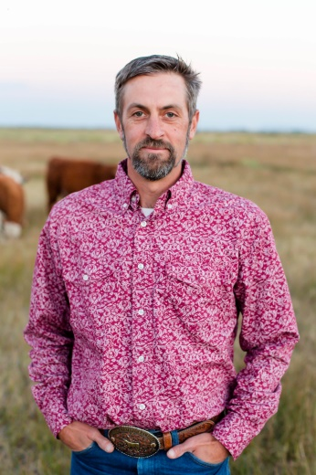
Hello, my name is Dave Pence. I am the owner of Rafter P Ranch Miniature Herefords and principle of the structural engineering consulting firm, Pence Engineering, LLC . My wife, Mikaila, and I live in the beautiful and diverse area of southern Colorado called the San Luis Valley. Although my wife and I are office professionals by training, we are enjoying the challenges and rewards of "hobby" ranching. Our ranch's mission is to provide our family, friends, and neighbors with the same high quality ranch beef we stock in our freezer while maintaining top genetics for success in the show ring. And while you'll find my wife and I bundled up on those cold mornings to feed and down on our knees combing and spraying on show day, it's never to the exclusion of our children at the lead because our top focus is to assure that they earn the pride, confidence, respect, and work ethic that come with raising and showing these wonderful animals. I am enjoying the opportunity to support youth beyond my own kids through the MHYF and I look forward to meeting you at the upcoming shows!

