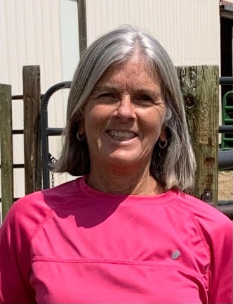
Hi, my name is Diane Jex. I live in Elbert, CO with my husband, Brian. We have two grown children and four grandchildren. I am retired from HP, where I held management positions for 21 years in HR Systems, Global Benefits Operations and Employee Mobility. My hobbies include gardening, baking, reading, and DIY projects. I am currently the Grants Director for MHYF and have been on the Junior Nationals committee for 2 years.
Our Miniature Hereford story began over 10 years ago on our one-acre faux farm in Nunn, CO with a fiberglass cow that we bought from the Denver Art Cow Parade. Fast forward to today and we own and operate Bent Nail Farm on just under 140 acres of prairie grass where we raise 30+ Miniature Herefords, an old horse, two fainting goats, a llama (that came with the property) and chickens.
We began raising Miniature Herefords with the objective of providing beef for our family, which we have been able to do and then some. As our herd has grown and we have become more involved with MHBA, we have slowly gotten more into the showing world with our granddaughters (and recently with one of their cousins). Never in my wildest dreams as a young adult or middle-aged person did I image that in my later years I would live in the country and be washing, combing/brushing, trimming and fitting cattle. Many life lessons have been learned and shared through the years.
I look forward to continuing the Jex family “Mini” journey and promoting the Miniature Hereford breed as members in good standing of the MHBA organization; participating in sanctioned shows (NWSS, Junior Nationals, Colorado Cattle Battle Series) as exhibitors and sponsors; and volunteering time and skills as board/committee members.

