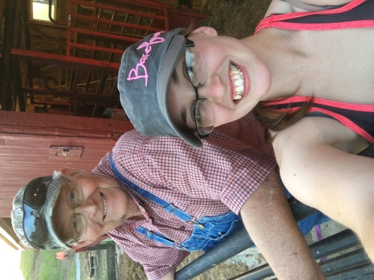

Hi, I am Leon Lamer of Marshalltown, Iowa. Leon and his wife own Carlee Farms where they breed Miniature Hereford cattle. Leon has retired as the CEO/General Manager of one of the larger Utility Company’s in the state of Iowa. Leon and his wife enjoy working with their cows and offer special deals to young people so they can own and show Miniature Herefords. The Lamar’s are stockholders in their County Fair and are always working to make sure that they can offer that great experience to as many youth as possible. We encourage you to contact Leon with any questions that you may have.

Contact Information:

Leon Lamer
641-751-9649
Email: leonlamer43@mediacombb.net

